**VIT UNIVERSITY: VELLORE**

SCHOOL OF INFORMATION TECHNOLOGY AND ENGINEERING

MS-SOFTWARE ENGINEERING

FALL-2013

**PROJECT REVIEW REPORT I**

**Project Title: SMART ATTENDANCE**

SUBMITTED BY

NAME(S) REG.NO(S) SIGNATURE OF STUDENTS

……………………. …………………… …………………………………………

A.Sai Praneeth 10MSE0066

G.Dinesh Chowdary 10MSE0018

**EVALUATED BY**

NAME AND SIGNATURE OF PANEL MEMBERS

1.

2.

3.

**INDEX**

**S. No Content**

**1. Abstract**

**2. Introduction**

**2.1. Purpose**

**2.2. Project Scope**

**3. Product Perspective**

**3.1. Existing System**

**3.2Proposed System**

**3.3. Product Features**

**4. Software Requirement Specification**

**4.1. Software Required**

**4.2. Hardware Required**

**5. Literature Survey**

**6. System Architecture**

**7. Design**

**7.1. Use Case Diagram**

**7.2. Class Diagram**

**7.3 Sequence Diagram**

**8. Implementation**

**8.1. Modules**

**9. References**

1. **Abstract**

We have seen over the years that the process of manual attendance has been carried out across almost all educational institutions. The process is not only time consuming but also sometimes inefficient resulting in the false marking of attendance. Today, we need not maintain pen and paper based attendance registers. Following this thought, we have proposed an attendance monitoring system based on the concept of web services which is implemented as an Android mobile application that communicates with the database residing on a remote server. The mobile application would require connecting to the database using either General Packet Radio Service (GPRS) or Wi-Fi technology.

1. **Introduction:**
   1. **Purpose:**

The concept of ***Web Services*** is not new and has been around for many years now. For a person who is unaware, a better way to understand it would be to consider the example of a user who might be interested in locating a public web service that gives the weather forecast in cities. Upon invocation, the web service will respond by giving information about which services are provided by which servers. Hence, now the user knows the location of the web service but doesn’t know how to invoke it. For this purpose, the web service needs to describe itself (tell us how the user should invoke it).The basic idea of a web service invocation involves sending of messages between a client and a server. For example, SOAP (Simple Object Access Protocol) specifies the format in which the requests are sent to the server and how the server should format the responses.

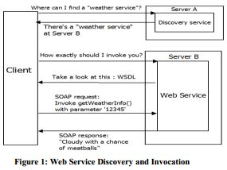

Now-a-days one of the fastest growing industries is mobile industry. The developers from this industry are doing research and development on new platforms & user experience and improving the technology. One such technology is ***Android*** from Google which is supported for most of the present generation phones.

**2.2 Project Scope:**

Our project aims to build this information system in a Mobile phone using the latest technology in the market namely Google Android SDK .This app is used missed calls, messages updates to the mail of user. This application is used to Record Attendance, modify and intimate students, parents about their attendance.

1. **Product Perspective**

**3.1 Existing System:**

In the existing system, professor takes the attendance manually and records the details of absentees or presenters. Using this records professor stores the student's attendance in each day in the attendance list and calculates the attendance percentage manually. In this system professor must consider each student separately and keep this list safely. It takes lot of time. Professor much spend more time to record each student attendance in the attendance list.

**3.2 Proposed System:**

Our system primarily focuses on building an efficient and user friendly Android mobile application for an Attendance Monitoring. The application will be installed on the user’s (in this case teacher’s) smart phone. It intends to provide an interface to the teacher who will require minimal details to input for marking of attendance of a particular class of students. Apart from that, the application would support strong user authentication and quick transmission of data via the web service.

Another noticeable feature of the application would be that it would send mail to parents in case if their ward is absent for a class and also its send a mail to students to intimate about their attendance if it is less than 75%.

**3.3 Product Features:**

* + It is easy to use and simpler way to upload attendance.
  + Sending Mail or SMS.
  + Helps Parents to keep track of their ward attendance.

1. **Software Requirement Specification**

**4.1 Software Requirements:**

* JAVA (JDK 1.6)
* Android SDK
* Eclipse IDE
* Operating System Windows 7 or 8

**4.2 Hardware Requirements:**

* RAM : 1GB and above
* Hard Disk : 20GB and above
* Processor : Dual Core

1. **Literature Survey**

*Title:* Mobile Phone based Attendance System

*Link:*<http://www.iosrjournals.org/iosr-jce/papers/Vol10-issue3/I01034850.pdf>

In this paper, the main aim is to develop an android application that helps the professor to take attendance through his/her mobile phone. This project will help the lecturers to reduce their workload by reducing the time and calculations required to update the attendance manually. Students and their parents will also view the attendance and curriculum details using the website.

This paper is similar to our project concept but in our project we are implement to some extra features like SMS or E-mail alert which will send an intimation to parents if their ward is absent for 2 days continuously. It will also intimate student with a warning message if their attendance percentage is less than 75%.

*Title:* Creating and Using SQLite Database for android applications

*Link:* <http://www.sersc.org/journals/IJDTA/vol5_no2/8.pdf>

This paper presents the overview of the Android platform towards software development for mobile and non-mobile applications. Android platform includes the popular open source SQLite database which has been used with great success as on-disk file format that allows the developer to handle data in a simple way. It includes overview of android platform, android architecture and it has some information about creating a SQLite Database.

Our project requires a database as it has to store all the attendance details of students of each day. However not all the data is stored in the mobile database but just the attendance data.

*Title:* A Mobile Application to Access Remote Database using Web Services

*Link:* <http://www.fcrit.ac.in/ncnte2012/library/comp_papers/paper3.pdf?.rxn=19732280>

In this paper, an Android based mobile application for Attendance Monitoring is presented. The application offers reliability, time savings and easy control. It can be used as a base for creating similar applications for tracking attendance in offices or any workplace. It can be also integrated in healthcare sector to keep track of nurse to patient visits by streamlining the time entry, time approval and management processes*.*

1. **System Architecture**

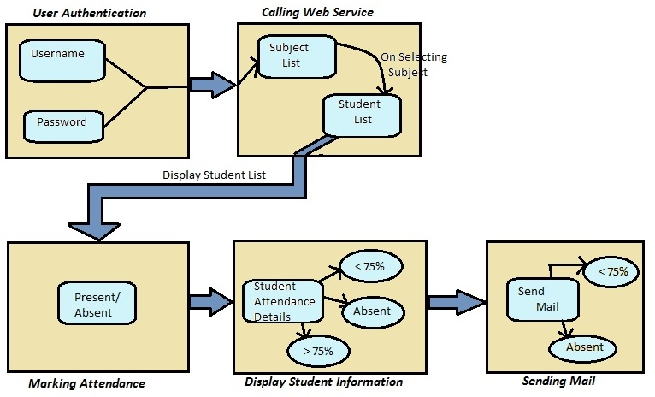

1. **Design**
   1. **Use-Case Diagram:**

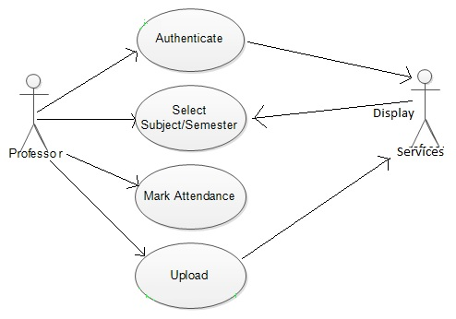

* 1. **Class Diagram:**

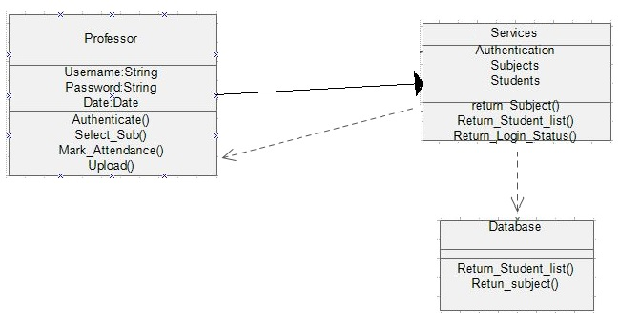

* 1. **Sequence Diagram:**

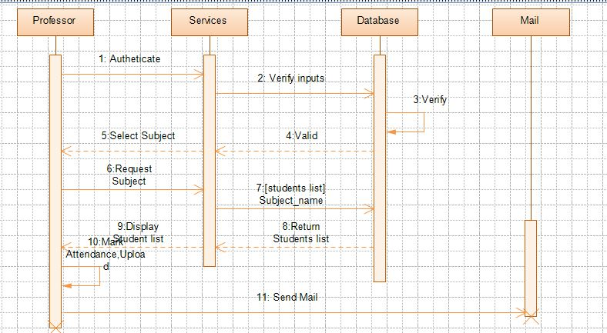

1. **Implementation**
   1. **Modules :**

Our proposed system is divided into five distinct modules described as follows:

1. ***User Authentication*** :

Initially, when the teacher runs the application for the first time, a login screen will be displayed that will prompt the teacher to enter the username and password required for authentication. The teacher will be provided with a unique username which would be a combination of alphanumeric characters. Only when the teacher enters the correct username and password, a “success” message will be displayed and the teacher will get authenticated and directed to the next screen.

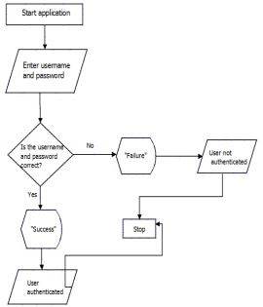

1. ***Calling a Web Service***:

In this module, the teacher will need to select details such as the name of the subject for which the lecture is being taken, time of lecture and the particular semester for which the lecture is conducted. After doing so, the teacher needs to call the web service by clicking a button provided on the screen. The web service thus invoked would return the list of names of all the students belonging to a particular semester and branch as per the input provided.

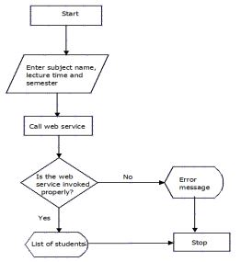

1. ***Marking Attendance***:

After the list of students has been displayed the teacher needs to begin the process of marking the attendance of students. For this purpose our application would be providing checkboxes against each student’s name that will allow the teacher to mark the student either present or absent. Accordingly, the details of the student will be sent to the remote database and the attendance will be marked for that particular day.

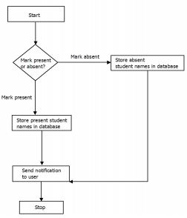

1. ***Display Student Information***:

Once the attendance has been marked successfully, the teacher can anytime check the attendance record of a particular student by entering the unique roll number provided to every student. The information thus displayed would include the student’s attendance percentage, number of lectures a student has attended for a particular subject, number of lectures missed, as well as the overall attendance.

1. ***Sending mail***:

Here the teacher has an extra option to send mail to the student who has the attendance percentage less than 75%.A mail will be sent to the parents about their ward attendance information if the students fails to attend a class.

**9.0 References**

[1] “Beginning Android 4 by Grant Allen Text Book” for basic Android application development.

[2] “Creating and using Database for Android application” by Sunguk Lee, International Journal of Database Theory and Application (Vol. 5, No. 2, June, 2012)

Link : <http://www.sersc.org/journals/IJDTA/vol5_no2/8.pdf>

[3] “A Mobile Application to Access Remote Database using Web Services” by Karan Balkar

Link: <http://www.fcrit.ac.in/ncnte2012/library/comp_papers/paper3.pdf?.rxn=19732280>

[4] “Mobile Phone Based Attendance System” by Shraddha S, IOSR Journal of Computer Engineering (IOSR-JCE).

[5] “Mobile Ubiquitous Attendance Monitoring System using Wireless Sensor Networks” by I-ChingHsu, ieee paper

Link: <http://ieeexplore.ieee.org/stamp/stamp.jsp?tp=&arnumber=5529624>